**Shell Lab Assignment 3**

1. Enter a shell command which will produce an error e.g. delete a file which does not exist. Check the exit status of the command which you just executed. Print out the deliberately erroneous command and the exit status which resulted, on your assignment submission

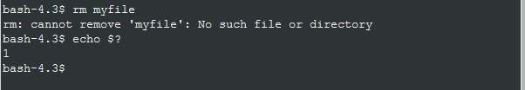

1. Enter a shell command which will run without an error e.g. list any file in the current directory. Check the exit status of the command which you just executed. Print out the command which ran without an error and the exit status which resulted, on your assignment submission.

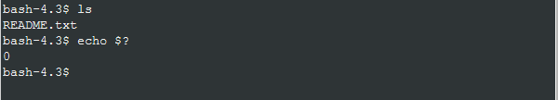

1. Write a shell script to print out the last 10 lines of a file. The name of the file to be printed (‘filename’) is to be supplied as a command line argument. If the file is successfully printed, the script should print out the message ‘file ‘filename’ found and successfully copied. Copy the shell script into your assignment submission.

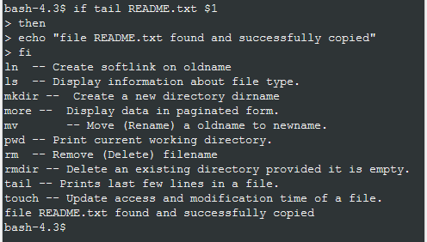

1. Write a shell script which takes any integer ‘x’ as an argument. If the number is negative, the script should print out the message ‘The number x is negative’. Otherwise it should print no output. Copy the shell script into your assignment submission.

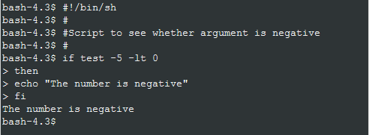

1. Write a shell script which uses the ‘if…then…else…fi ‘ statements to check on the sign of a number. It should first check to see if a number has been supplied on the command line. If not it prints an error message and terminates. If so, it prints out a message stating that the number is positive or negative or zero. Copy the shell script into your assignment submission

